****Project objective:****

As a developer, write a program to create an arithmetic calculator.

****Background of the problem statement:****

As a developer, write a Java code to create a calculator to perform the four basic arithmetic operations (addition, subtraction, multiplication, and division).

**Source Code :-**

**package** com.Simplilearn.Calculator;

**import** java.util.Scanner;

**public** **class** ArithmeticCalculator {

**public** **static** **void** main(String[] args) {

Scanner sc=**new** Scanner(System.***in***);

System.***out***.println("Enter the two numbers");

**int** firstnum=sc.nextInt();

**int** secnum= sc.nextInt();

System.***out***.println("Enter the operator ");

**char** op=sc.next().charAt(0);

**double** Ans=0;

**switch**(op) {

**case** '+': Ans=firstnum+secnum;

**break**;

**case** '-':Ans=firstnum-secnum;

**break**;

**case** '*': Ans=firstnum*secnum;

**break**;

**case** '/':Ans=firstnum/secnum;

**break**;

}

System.***out***.println("the answer is " +Ans);

}

}

**Output :-**

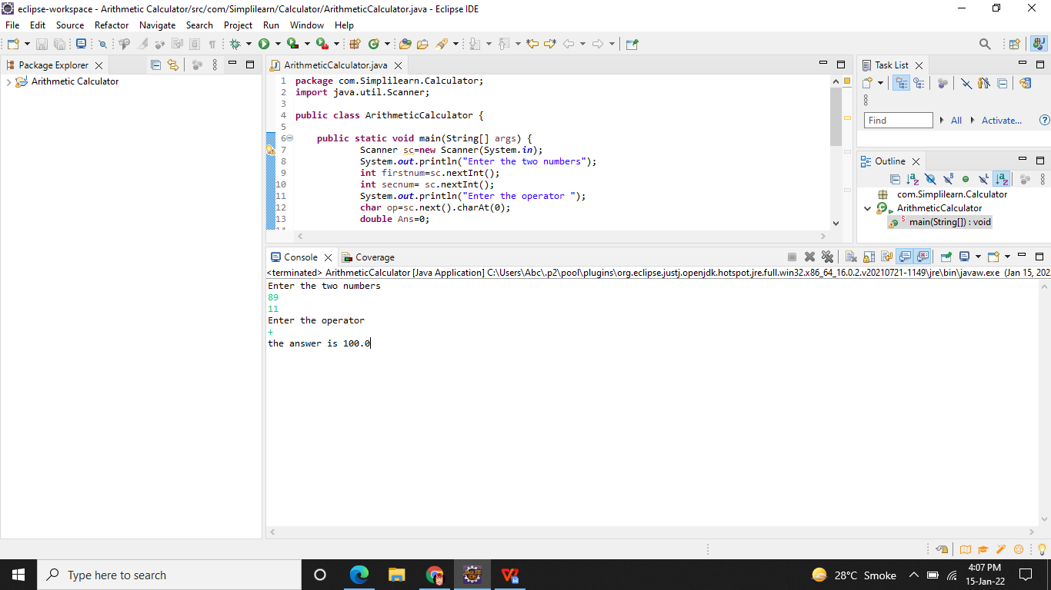

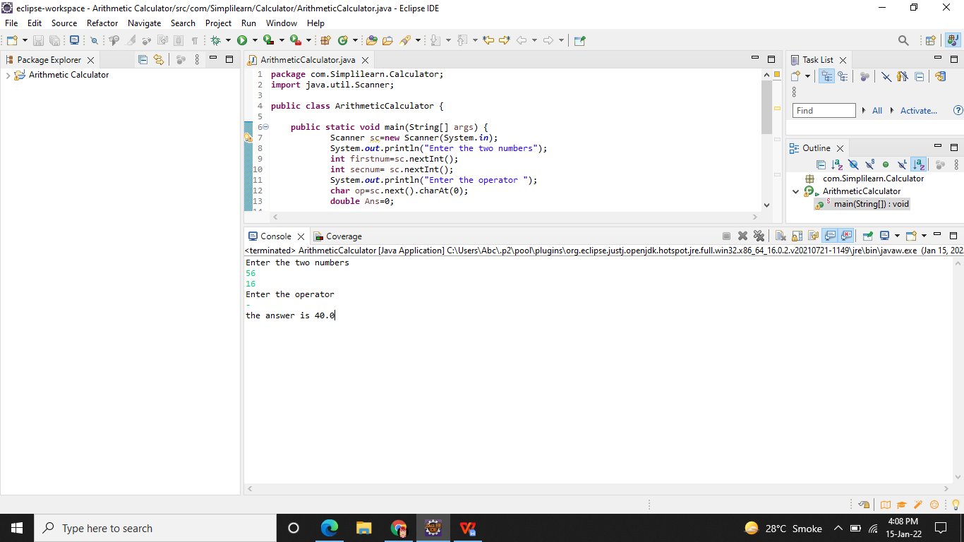

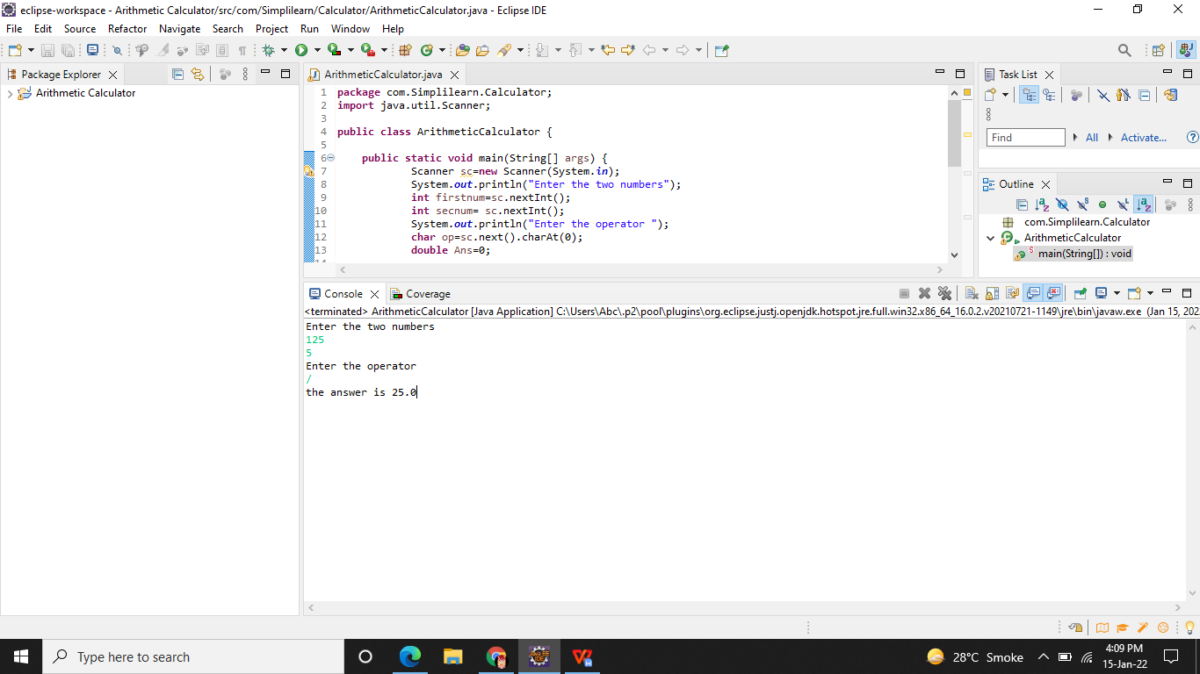

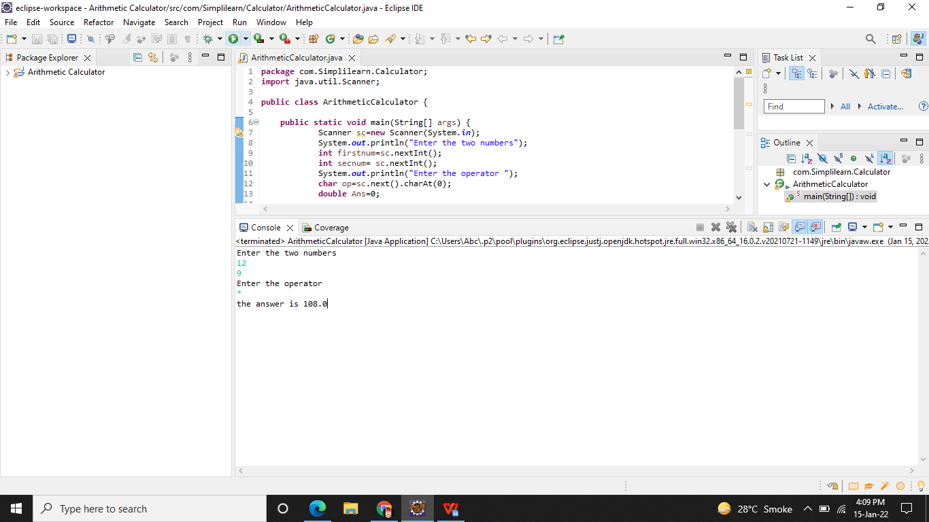

**Github Link -**

**https://github.com/Aniket03-op/Project.git**